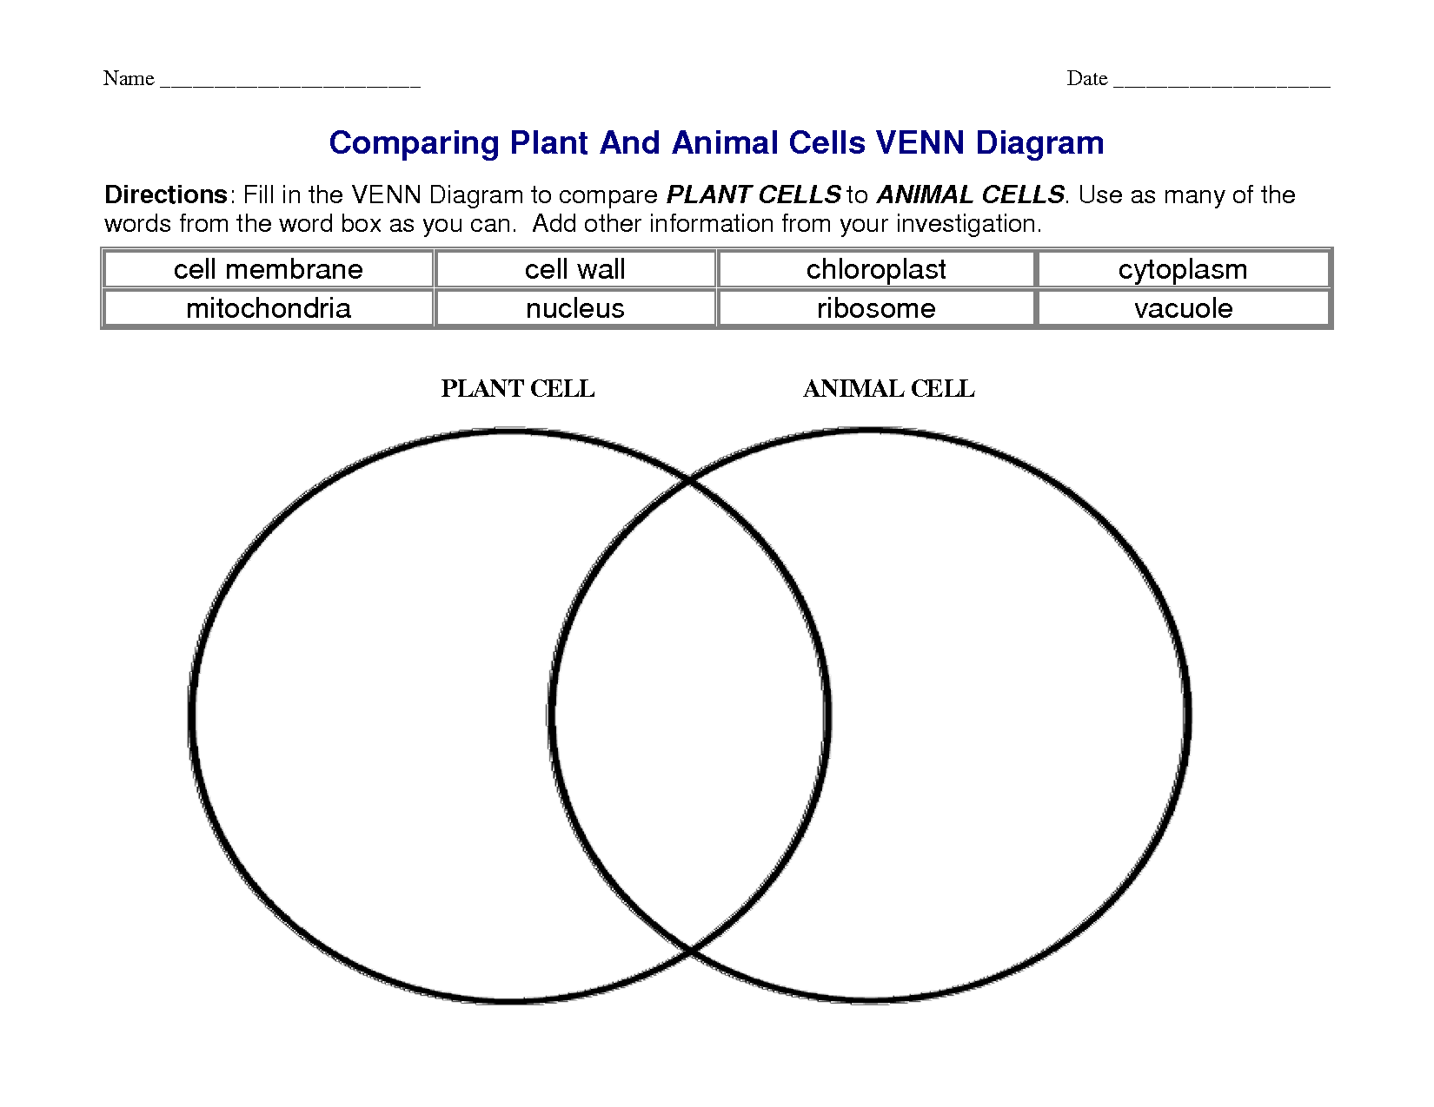

II. Direction : Fill in the blanks with an appropriate word. Write minus wrong.
Plants and animals are living things. All plants and animals are made of _______. The _____ is a layer around the outside of the cells. Plant cells have an additional layer called the _____ that provides extra support.______ is a gel like substance inside the cell membrane. All activity in the cell is controlled by the ________._________ break down food and turn it into energy for the cell to use. Water , food, and wastes are stored in the __________ of the cell. A green chemical called _______ is in the _________ of plant cells. Plant cells turn energy from ________ into food. People didn’t know that cells existed until they could see them under a __________.

II. Read with comprehension.
STEM CELL Projects
Stem cells are cells that divide to produce all other types of specialized cells. Most of the rapidly dividing cells of a one –week – old embryo are considered to be stem cells.
Stem cells can be used in the treatment of Parkinson’s disease , Alzheimer’s disease, diabetes, spinal cord injury ,and multiple sclerosis. They are used to improve a person’s features as they are found to contained anti – aging properties.In some countries , Stem cells are used in expensive facelift surgeries. Different stem cell projects and researches are being undertaken at present.
The researches and projects , however are the subject of moral argument., especially with regard to the use of human embryos. Some research centers propose to use frozen human embryos left over from fertility treatments.
The following moral arguments have been presented :
1.Stem-cell researchers claim that it is just a few cells, an insignificant number , that must be disposed of.
2.Human Reproductive Act maintains that an embryo is a human organism as early as 56 days.
What is your reaction to these arguments presented ?

IV. Answer briefly.
1.You are a researcher and a microscope is unavailable, how would you determine if there are microscopic organisms present in a sample of pond water ?

2. Where would you expect to find more mitochondria , in a skin cell or a muscle cell ? Explain your answer.

V. Make a short story about cell structure.

VI. Give the significant contributions of each of the following to what we know about the cell today.
- Robert Hooke
- Robert Brown
- Anton van Leeuwenhoek
- Matthias Schleiden and Theodor Schwann
- Rudolf Virchow
VII. State the Cell Theory.

